20160810 Masood Ahmed (masood4ahmed@gmail.com)

TWC Exercise:

Link to github project:

<https://github.com/ma4git/twc.git>

The RESULT directory holds the outputs for the curl commands.

Here is a link to the demo video on youtube:

<https://www.youtube.com/watch?v=EQlMmhCiQII>

Please complete the following:

*In your operating system of choice, write a chef cookbook to configure Nginx or similar service as a reverse proxy for multiple backend services.  
   requests starting with /bing should redirect to* [*http://www.bing.com*](http://www.bing.com) *requests starting with /weather should redirect to* [*https://weather.com/weather*](https://weather.com/weather)

*We expect to verify the functionality by making requests against this server like so:  
   curl 'http://localhost/bing/search?q=hello'  
   curl 'http://localhost/weather/today/l/USGA0028:1:US'*

*And comparing equivalent requests against the sources:  
    curl 'http://www.bing.com/search?q=Hello'  
    curl 'https://weather.com/weather/today/l/USGA0028:1:US'*

*Finally, using the same cookbook created above, extend the ephemeral port range so it begins at 20000 and ends at 64000.*

*To get acquainted with Chef and familiar with writing and running cookbooks, we suggest the "Learn the basics” tutorial here:*[*https://learn.chef.io/tutorials/*](https://learn.chef.io/tutorials/)

*Please return the completed cookbook to us by either:*

*● Sending us a link to a public git repository (e.g. github or bitbucket) repository, or*

*● Emailing us a zip file*

This exercise involved learning chef, nginx, and git (with github).

Ideally, a chef server, chef workstation, and a node should have been setup; however, due to time constraints and for the purpose of demoing a chef recipe, the exercise was performed on a stand-alone chef workstation.

Below are screen shots of redirects to backend services using nginx.

Browse to localhost:

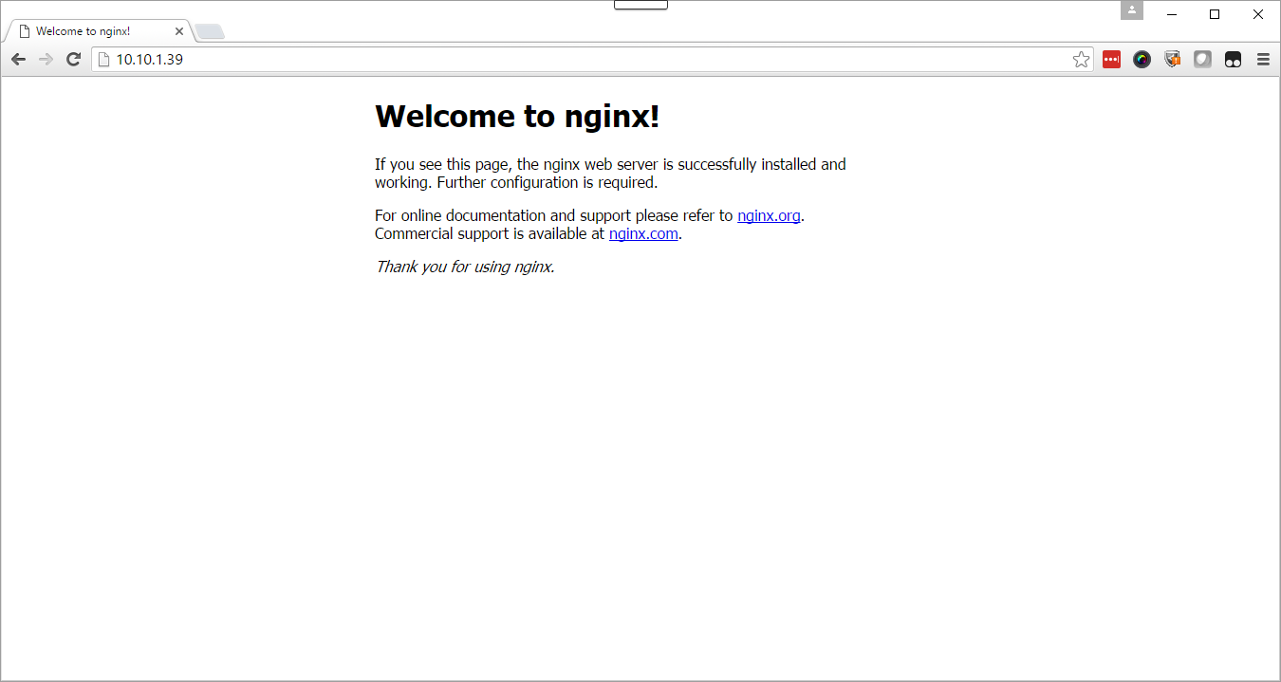

http://10.10.1.39/bing/

For some reason this redirect to [www.bing.com](http://www.bing.com) does not load. Tried several other websites and they all worked. Maybe bing does not allow redirects in this manner. There may be a setting in Nginx that can solve this problem.

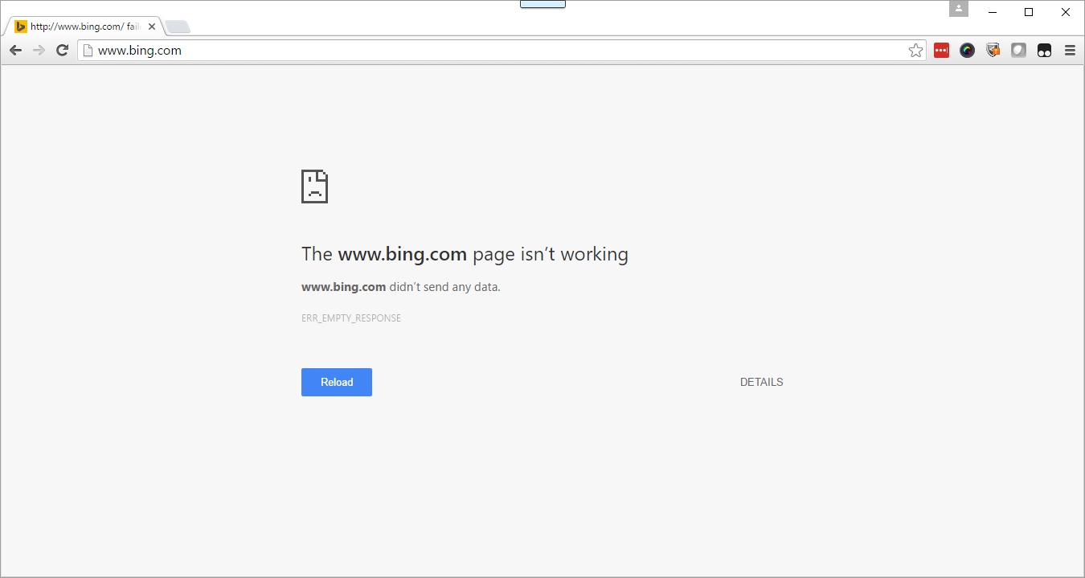

http://10.10.1.39/weather/

This redirect works as desired.

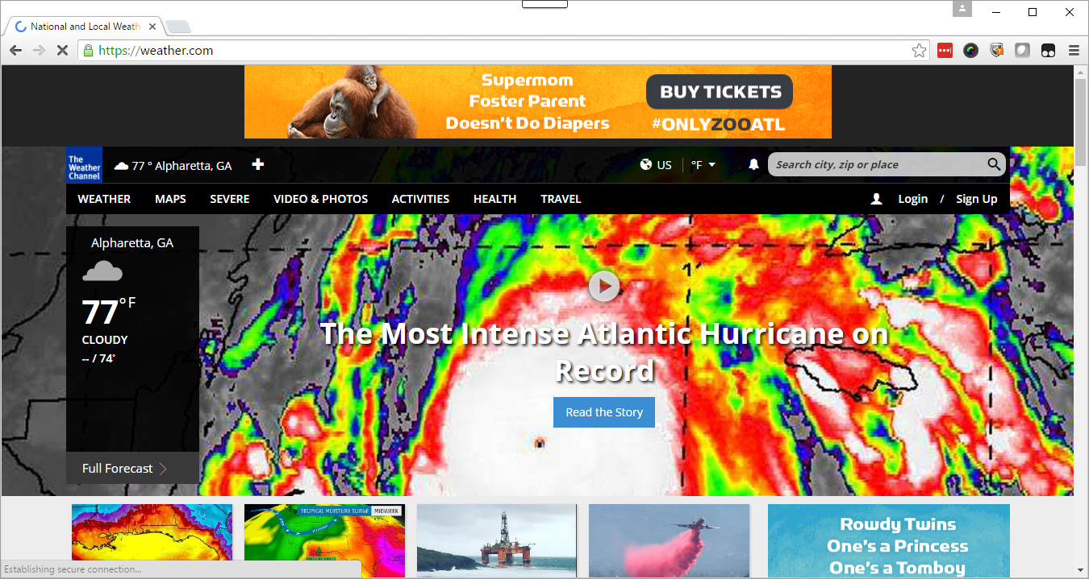

When running curl against a page that is redirected, get the following message:

[root@chef-wkst conf.d]# curl 'http://localhost/bing/search?q=hello'

<html>

<head><title>301 Moved Permanently</title></head>

<body bgcolor="white">

<center><h1>301 Moved Permanently</h1></center>

<hr><center>nginx/1.10.1</center>

</body>

</html>

Had to use the –L option for curl since nginx reports that the requested page has been moved to a different location. The –L option causes curl to resend the request to the new location.